**SRS DOCUMENT FOR ONLINE SHOPPING MART**

**ABSTRACT**

TheOnline Shopping Mart can make shopping easier and its purpose is to provide a convenient and efficient way for customers to purchase products.The Online Shopping Mart is a web-based application, designed to provide a user-friendly platform for purchasing products online. The key functionalities of this system are adding items to the system, browsing items, adding items to the cart, placing orders, and tracking orders. Through this document, the client will get insight into the functional and non-functional requirements of the system, ensuring the development team's understanding of the system objectives.

**FUNCTIONAL REQUIREMENTS**

* User Registration and Authentication
* System Management
* Browsing Products
* Cart Management
* Order Processing

**NON-FUNCTIONAL REQUIREMENTS**

* Security
* High Performance
* Scalability
* Usability

**MODULAR DESCRIPTION**

1. User Registration and Authentication

In this module, each user should create an account with a unique username and password. The password must be strong with constraints like at least 1 ( Upper case, lower case, digit, and special character) so, that the user can securely log in to the website.

2. System Management

In this module, the admin has access to add, delete, and update products on the website.

3. Browsing Products

In this module, the user will able to search products and filter them based on various categories. so, that the user can easily view the desired product and add it to the cart.

4. Cart Management

In this module, the user can able to add and remove items to the cart. The shopping cart should display the total number of items and price.

5. Order Processing

In this module, the user will place an order, enter an address for delivery, and make a payment. Users should be provided with various kinds of payment methods. They are also able to track orders and cancel orders.

**FLOW CHART**

Register/ Log in

Track Order

Make Payment

Place Order

Add product to cart

Browse Product

**USE CASE DIAGRAM**

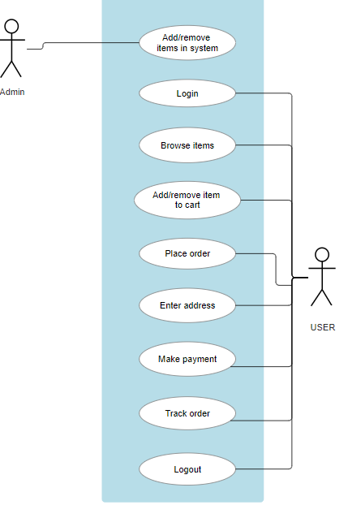

**CLASS DIAGRAM**

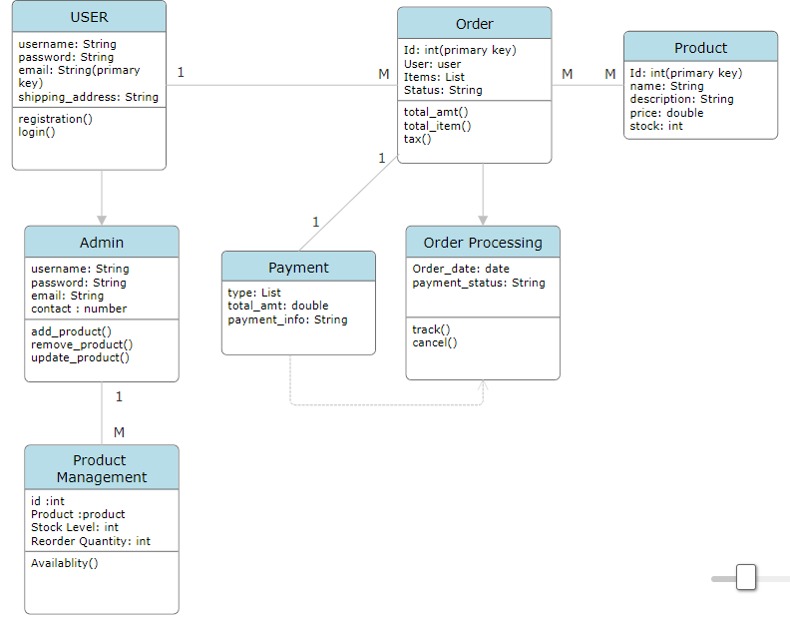

**SEQUENCE DIAGRAM**

